AngaVeritas
Investment Intelligence & Ground Verification
May 2026

Table of Contents
1. Executive Summary
2. Company Overview
3. Vision, Mission & Values
4. Problem Statement
5. Market Opportunity
6. Customer Segments
7. Service Offerings
8. Revenue Model & Pricing Logic
9. Operational Strategy
10. Customer Journey
11. Dashboard & Technology Platform
12. Marketing & Growth Strategy
13. Legal & Compliance Framework
14. Risk Management
15. Strategic Roadmap
16. Financial Philosophy
17. Competitive Landscape
18. Long-Term Strategic Vision
19. Conclusion

1. Executive Summary
AngaVeritas is a Kenyan investment intelligence and ground verification company designed to reduce uncertainty before capital deployment. The business provides independent, evidence-based, on-the-ground intelligence for local and diaspora investors seeking to invest in Kenya.
The company exists to solve one of the biggest problems in emerging-market investing: information asymmetry. Many investors enter ventures with inadequate understanding of local market conditions, hidden operational realities, fraudulent actors, or weak feasibility.
AngaVeritas positions itself as a trusted operational visibility and decision-support partner by combining field verification, structured reporting, market intelligence, and technology-enabled monitoring.

2. Company Overview
- Business Name: AngaVeritas
- Business Type: Investment intelligence and ground verification company
- Primary Target Market: Kenyan diaspora and local Kenyan investors
- Core Value Proposition: Independent verification and operational visibility before capital deployment
- Primary Services: Ground verification, feasibility analysis, construction monitoring, supplier verification, investment intelligence

3. Vision, Mission & Values
- Vision: To become the most trusted investment intelligence infrastructure company in Kenya
- Mission: To empower investors with objective, evidence-based intelligence before they commit capital.
- Core Values: Integrity, objectivity, transparency, accountability, professionalism, evidence-first reporting

4. Problem Statement
Kenya’s investment environment contains significant information gaps. Many investors make decisions using incomplete, biased, outdated, or unverifiable information.
Diaspora investors are particularly vulnerable because they are physically disconnected from projects and often rely on relatives or intermediaries whose incentives may not align with theirs.
This results in failed projects, fraud exposure, capital losses, construction delays, poor feasibility decisions, and operational inefficiencies.

5. Market Opportunity
- Diaspora Market: Millions of Kenyans abroad remit and invest billions annually while lacking trusted visibility into projects.
- SME Growth: Kenya’s growing SME ecosystem creates demand for independent feasibility and verification services.
- Trust Gap: There is increasing demand for objective and independent verification infrastructure.
- Technology Opportunity: A dashboard-enabled oversight model creates long-term recurring revenue potential.

6. Customer Segments
- Diaspora Investors: Individuals investing in SMEs remotely
- Local First-Time Investors: Professionals and entrepreneurs seeking feasibility guidance
- SMEs: Businesses seeking operational intelligence or market-entry analysis
- Institutional Clients: Future expansion into SACCOs, banks, NGOs, and investor groups

7. Service Offerings
- Ground Verification: Independent site inspections, existence verification, and operational visibility
- Business Feasibility Studies: Market analysis, operational risks, cost structures, and demand assessment
- Supplier Verification: Independent verification of suppliers, contractors, and partners
- Market Intelligence Reports: Sector and county-level investment insights
- Retainer Oversight: Ongoing project monitoring and recurring reporting

8. Revenue Model & Pricing Logic
AngaVeritas will adopt a hybrid pricing model designed to balance transparency, operational sustainability, and scalability.

8.1 Pricing Philosophy
Clients are not paying merely for transport or reports. They are paying for reduced uncertainty, operational visibility, independent intelligence, and protection from costly investment mistakes.

8.2 Operational Cost Logic
Fuel efficiency assumptions are built into pricing due to differing traffic and travel realities within and outside Nairobi.
Travel Zone | Fuel Efficiency | Pricing Logic | Additional Charges
Within Nairobi | Approx. 8 km/liter | (Distance ÷ 8) × Fuel Price | Parking, waiting time, operational buffer
Outside Nairobi | Approx. 11 km/liter | (Distance ÷ 11) × Fuel Price | Per diem, accommodation if necessary
Recommended operational buffer: 15–25%

8.3 Pricing Packages
Package | Price Range | Scope
Basic Verification | KES 15,000–30,000 | Single inspection, visual evidence, summary report
Standard Investigation | KES 40,000–80,000 | Interviews, structured reporting, deeper verification
Comprehensive Due Diligence | KES 100,000–300,000+ | Multi-day investigations, risk analysis, extensive reporting
Retainer Oversight | KES 25,000–250,000+/month | Recurring inspections and ongoing visibility

9. Operational Strategy
AngaVeritas will initially operate with a lean but highly structured field intelligence model.
- Core Team: Founders, legal advisor, accountant, analysts, field verification agents
- Infrastructure: Cloud storage, CRM, reporting templates, dashboard system, secure communication channels
- Field Operations: Site inspections, evidence collection, interviews, market observation
- Quality Control: Structured checklists, standardized protocols, multi-stage report review

10. Customer Journey
- Awareness: Client discovers AngaVeritas through referrals, content, or diaspora communities
- Inquiry: Client submits project or investment concern
- Consultation: Scope definition, needs assessment, proposal generation
- Onboarding: Dashboard setup and project initiation
- Field Verification: Inspection, evidence collection, interviews
- Analysis: Transformation of field data into actionable intelligence
- Reporting: Delivery of reports and dashboard updates
- Retention: Long-term monitoring and recurring oversight

11. Dashboard & Technology Platform
The AngaVeritas dashboard acts as a mission-control platform for investors. Its purpose is to transform fragmented field information into structured operational visibility.
- Project health indicators
- Risk alerts and escalation
- Inspection timelines
- Interactive Kenya map
- Photo and video evidence archive
- Construction monitoring updates
- Market intelligence feeds
- Client communication portal
- Document and report archive
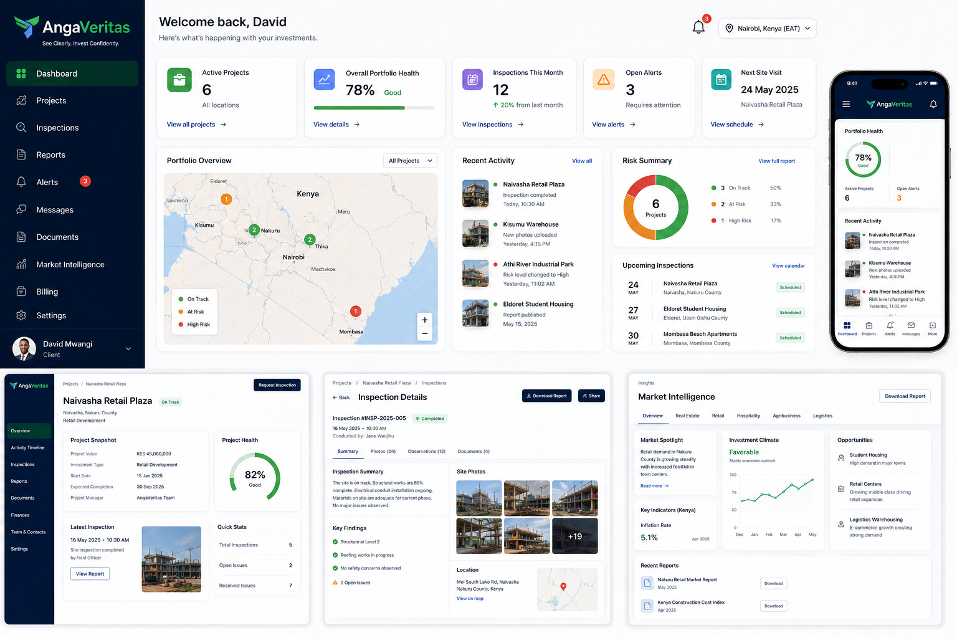

12. Marketing & Growth Strategy
- Content Marketing: Educational content around investment mistakes, fraud prevention, and market insights
- Diaspora Communities: Partnerships with diaspora groups and associations
- Referral Network: Lawyers, accountants, real estate professionals, SACCOs
- Thought Leadership: Publishing market intelligence and feasibility insights

13. Legal & Compliance Framework
- Legal Structure: Private Limited Company
- Compliance: KRA registration, county permits, data protection compliance
- Contracts: Service agreements, NDAs, liability disclaimers
- Insurance: Professional indemnity insurance recommended

14. Risk Management
- Credibility Risk: Mitigated through professionalism, transparency, and structured reporting
- Liability Risk: Mitigated through disclaimers and contractual scope definition
- Operational Risk: Managed via standardized field procedures
- Scalability Risk: Addressed through technology and systems standardization

15. Strategic Roadmap

Immediate Goals (0–12 Months)
- Register company and establish operational foundation
- Develop reporting systems and dashboard MVP
- Acquire first clients and build case studies
- Develop field agent network

Intermediate Goals (1–3 Years)
- Launch retainer monitoring services
- Expand county coverage
- Develop subscription intelligence products
- Strengthen diaspora partnerships

Long-Term Goals (3–7 Years)
- Become Kenya’s leading investment intelligence platform
- Expand into East Africa
- Develop institutional due diligence services
- Launch scalable technology-enabled intelligence platform

16. Financial Philosophy
The company’s early-stage focus is on credibility, operational systems, and trust-building rather than immediate scale.
Long-term financial sustainability will come from recurring revenue through retainers, subscriptions, and intelligence products.

17. Competitive Landscape
Existing competitors are fragmented across investigations, real estate due diligence, and corporate intelligence.
AngaVeritas differentiates itself by combining operational visibility, investor psychology, dashboard-enabled monitoring, and diaspora-focused trust infrastructure.

18. Long-Term Strategic Vision
AngaVeritas ultimately aims to become foundational investment intelligence infrastructure for Kenya and East Africa.
The company’s long-term moat will be trusted field intelligence networks, structured operational visibility, and proprietary data systems.

19. Conclusion
AngaVeritas addresses one of the most persistent problems in emerging-market investing: uncertainty before capital deployment.
By combining technology, field intelligence, structured reporting, and investor-focused operational visibility, the company is positioned to become a trusted decision-support partner for investors across Kenya and the Kenyan diaspora community.

